In Spring, conditional bean initialization can be achieved using the @Conditional annotation or @ConditionalOnProperty from Spring Boot. These annotations allow you to load a bean based on specific conditions, such as the presence of a property, its value, or custom logic.

1. Using @ConditionalOnProperty
@ConditionalOnProperty is a Spring Boot annotation that allows conditional bean initialization based on a specific property value in the application's configuration (e.g., application.properties or application.yml).

Syntax
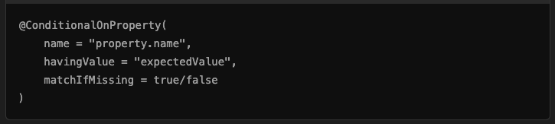
- name: The name of the property to check.
- havingValue: The value the property must have for the bean to be initialized.
- matchIfMissing: (Optional) If true, the condition matches when the property is not defined. Default is false.

Example: Conditional Bean Initialization Based on a Property
application.properties

Java Configuration
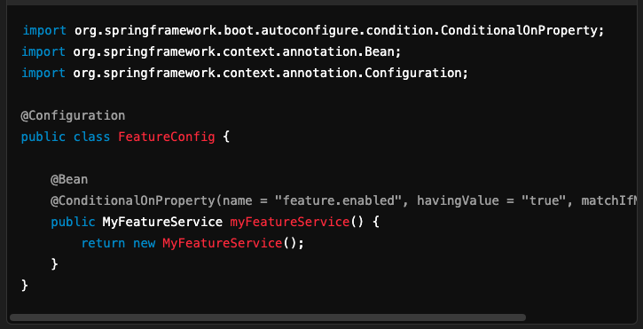
Explanation:
- The bean MyFeatureService will only be created if the property feature.enabled is set to true.
- If feature.enabled is not set, the bean will not be created because matchIfMissing is false.

2. Using @Conditional with Custom Conditions
The @Conditional annotation is more generic and allows you to define custom logic by implementing the Condition interface.

Steps
- Create a Custom Condition Implement the Condition interface and override the matches method.
Example: Custom Condition
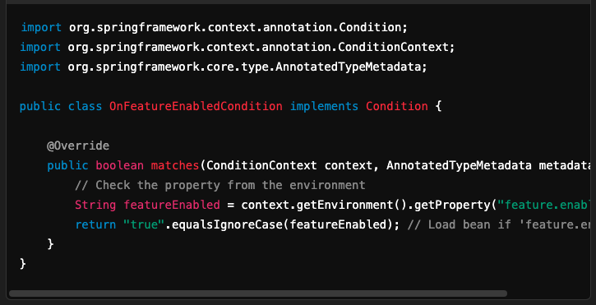
- Use the Custom Condition in a Configuration
Java Configuration
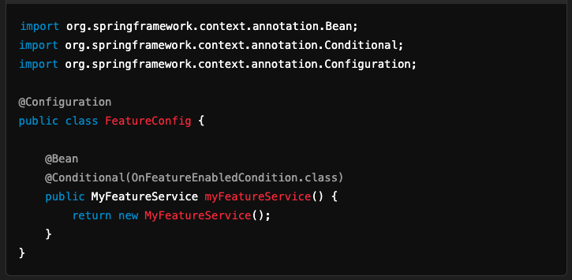

Explanation:
- The MyFeatureService bean will only be initialized if the OnFeatureEnabledCondition's matches method returns true.

3. When to Use Which Approach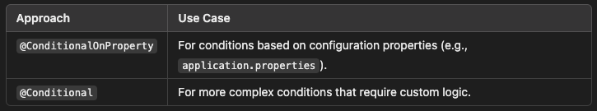

4. Example with Multiple Conditions
You can combine conditions for more complex requirements.
Example: Combine Multiple Properties
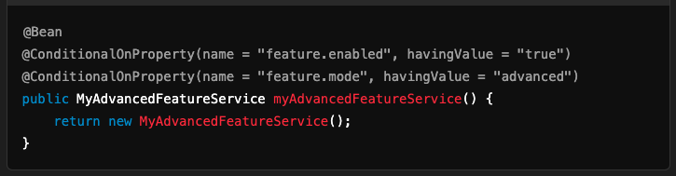

5. Testing Conditional Beans
To verify if conditional beans are loaded:
- Use the Spring Boot actuator's /actuator/beans endpoint (if enabled).
- Write a test case to assert the presence or absence of the bean.
Example Test Case
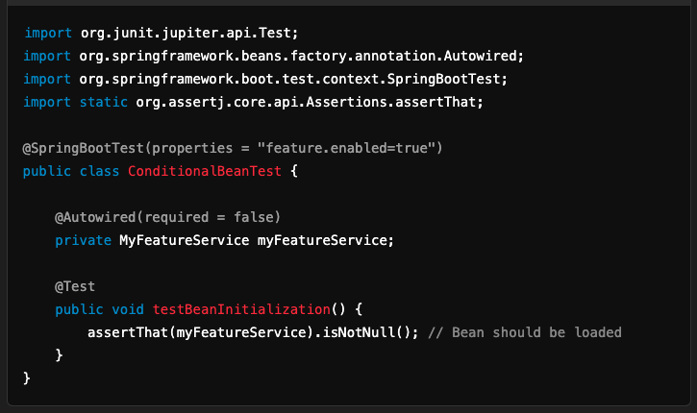

Conclusion
- Use @ConditionalOnProperty for property-driven conditional initialization.
- Use @Conditional for custom logic.
- Both approaches help in building flexible, configuration-driven applications.

